AWS Assignment 6

Task 1
Host a static website using s3 as follows:
- Buy a domain from Freenom as yourname.opstree.com
example: yashvinderopstree.com (Don't worry it's free)
- Migrate this domain to Route53
- Host a static website using s3 bucket
Solution:

- Signup on freenom website and buy a free doamin (hemantkhokharopstree.ml)
- Created a hosted zone using Route 53 service
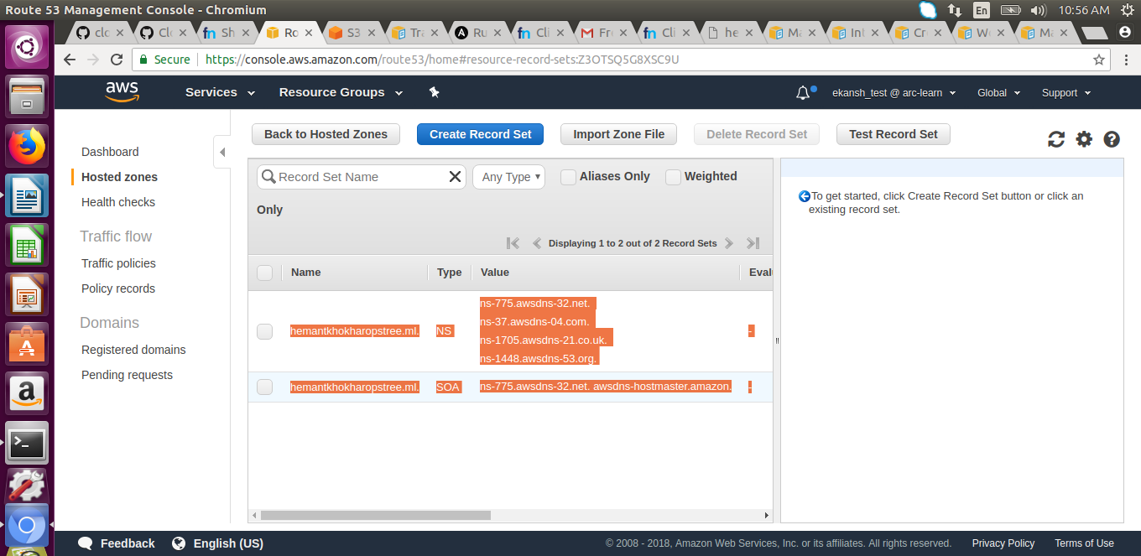

- Open free nom domain configuration webpage and point domain name to AWS name servers.
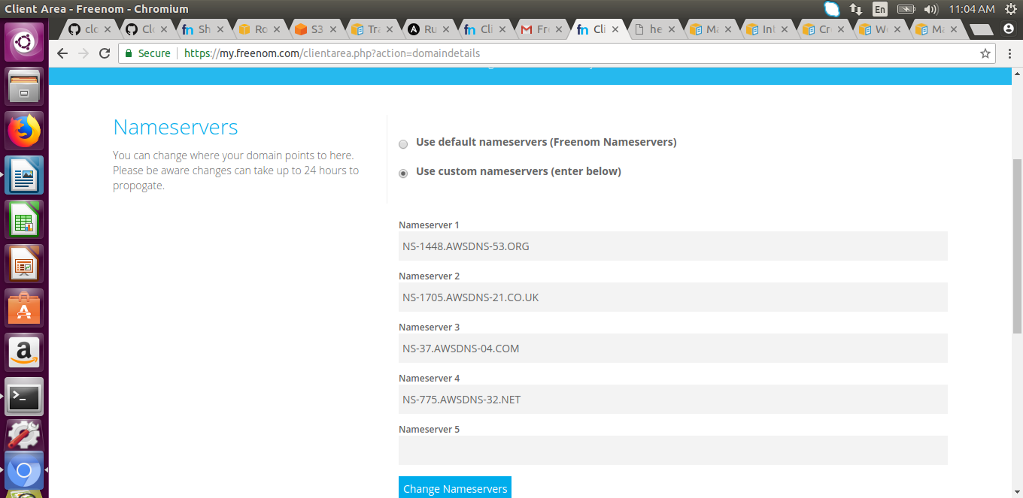

- Created a bucket (keeping publicly accessible) namely “hemantkhokharopstree.ml” i.e of the same name as of domain name

- Uploaded indes.html file into it which will open up when opening the domain name

- Make request from hemantkhokharopstree.ml redirects to this bucket
